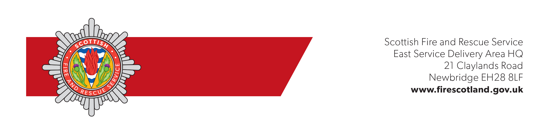

zelada.monica@gmail.com | Contact | Mr Ferguson
zelada.monica@gmail.com | Direct Line | 07345 234 504
zelada.monica@gmail.com | E-mail | christopher.ferguson@firescotland.gov.uk
zelada.monica@gmail.com | Our Ref  Your Ref | ESDA/EWWM/CF/906109401  561985
zelada.monica@gmail.com | Date | 19 March 2026
Dear Monica,

FIRE (SCOTLAND) ACT 2005: PART 3
THE FIRE SAFETY (SCOTLAND) REGULATIONS 2006
SHORT TERM LET (STL) LICENCE APPLICATION / RENEWAL

NAME AND ADDRESS OF PREMISES: | Kellerstain Stables, 9 Gogar Station Road, Edinburgh, EH12 9BS
TYPE OF OCCUPANCY: | Short Term Let
DUTYHOLDER: | Monica Zelada

Following receipt of your fire safety checklist for the above-named premises, a number of fire safety areas for improvement were identified. A Scottish Fire and Rescue Service enforcement officer has reviewed these areas for improvement, and you are hereby informed that the fire risk assessment should be reviewed to take cognisance of the following matters:

1. | Managing Fire Safety  You should prepare a plan of what action any occupier should take in the event of fire. This would include the route of escape, how to raise the alarm and how to call the Fire Service. This should be available for each party on arriving at the premises. A simple notice could be fixed in an easily visible place such as the hall and bedrooms and be provided within a welcome pack. You should also ensure that the occupier is advised of basic precautions such as closing doors at night to inhibit the spread of smoke, and the need to inform the owner or agent if any equipment develops a fault (such as electrical or smoke alarm defects).
2. | Means of Escape  If a fire disrupts the normal lighting there should be sufficient illumination for occupants to find their way out of the property. Where an escape route does not receive adequate illumination from a street light or other external source, alternative lighting should be provided. This could be through ensuring that the hall and landing (if applicable) have one or more automatic plug-in night lights of a type which continue to operate if the mains electricity fails.  Where additional lighting is provided, you should establish a system which ensures that the plug-in light or other lighting is present and in working order at the commencement of each let.

3. | Where the direction to escape routes is not apparent, intermediate signs, incorporating pictograms and directional arrows should be provided to comply with the Health and Safety (Safety Signs and Signals) Regulations and/or British Standard 5499: Part 1 current edition.

The above risk control measures should not be regarded as the only option for achieving the benchmark standards. Other fire safety risk assessment methods or fire safety measures which achieve the same end may be considered.

You are however, reminded that the process of fire safety risk assessment should be ongoing. If there is reason to suspect that the current fire safety risk assessment is no longer valid, or if there has been a significant change in the matters to which it relates, then the assessment must be reviewed by the dutyholder and any changes in the fire safety measures required must be made to ensure continued compliance with the said Act and Regulations.

Where to get advice or further information

More detailed guidance on the Act and Regulations and fire safety risk assessment is available by clicking here, or by visiting https://www.firescotland.gov.uk/businesses-and-landlords/

Free advice is available from the SFRS on technical details and options for compliance, however the dutyholder is responsible for carrying out the fire safety risk assessment for their premises; and identifying and implementing the fire safety measures necessary as a result of the findings of the fire safety risk assessment.

The SFRS is committed to the provision of a high-quality service to the communities it serves. To ensure we maintain our high standards of service delivery, we are seeking the views of our dutyholders who have engaged with our Protection Officers, and we would appreciate feedback on your experience before, during and after the audit. Please click here to complete a short questionnaire or scan the QR code below.



Should you require further information or clarification in relation to this letter, please do not hesitate to contact the above named officer at the following address SFRS, Newbridge ARC, 21 Claylands Road, Newbridge, EH28 8LF.

Yours faithfully,

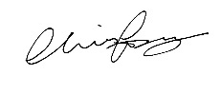

pp
Area Commander David Dourley
LOCAL SENIOR OFFICER
City of Edinburgh

cc: Mariya.Koleva@edinburgh.gov.uk

